Active Students forecast
Investigating the trends
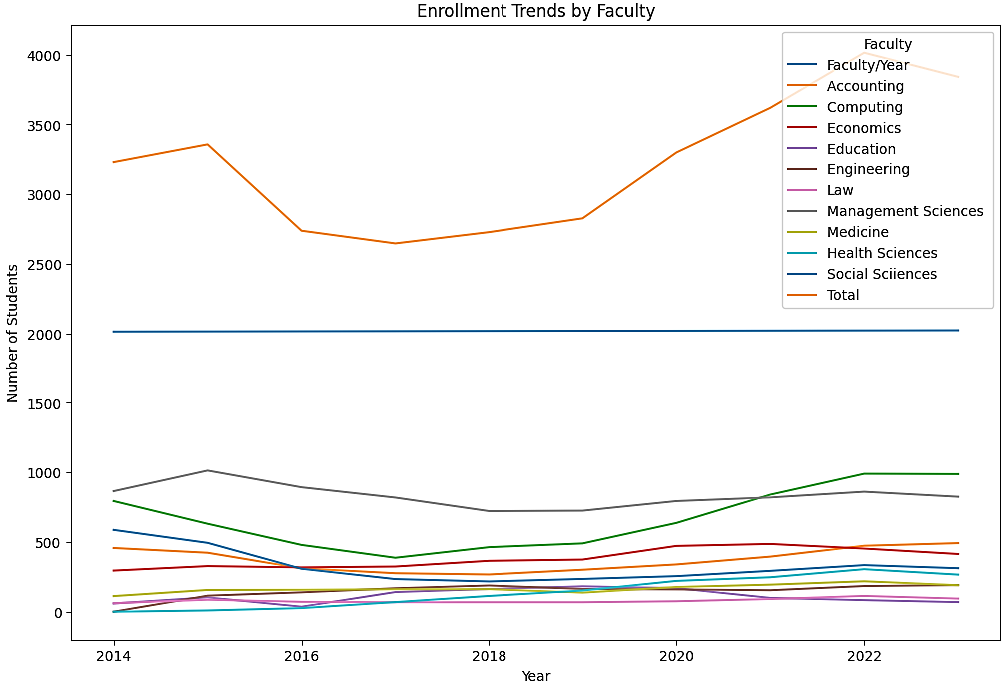
1. Overall active undergrad students
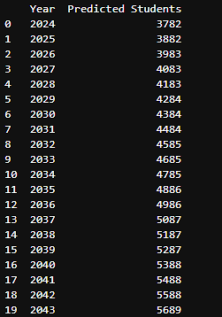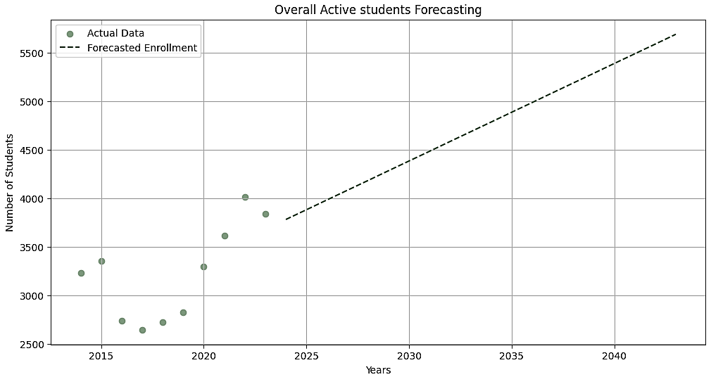
2. All master programs
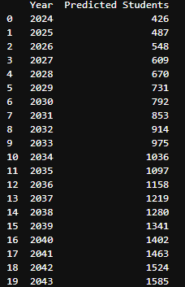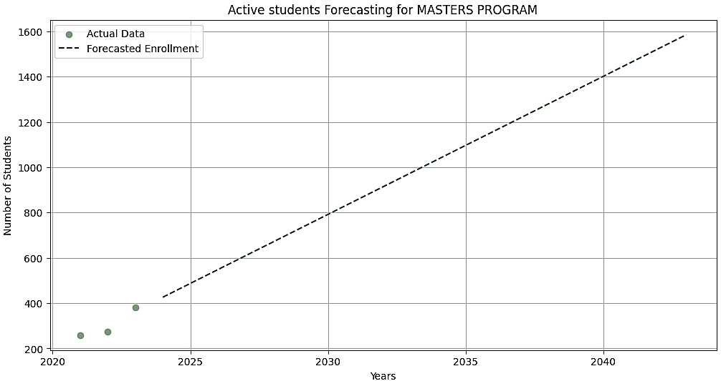

3. Faculty of Accountancy
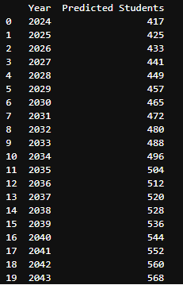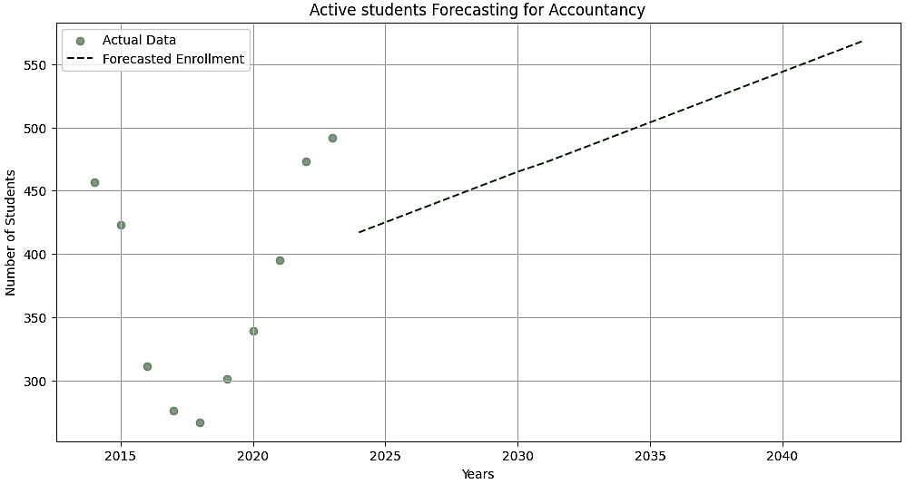

4. Faculty of Computing
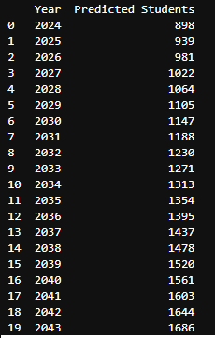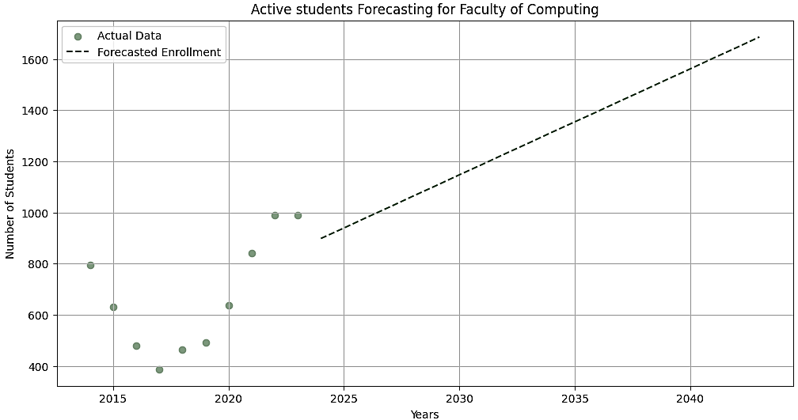

5. Faculty of Economics
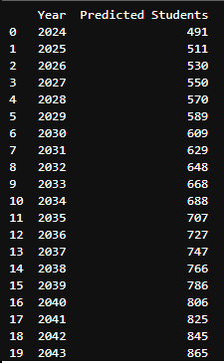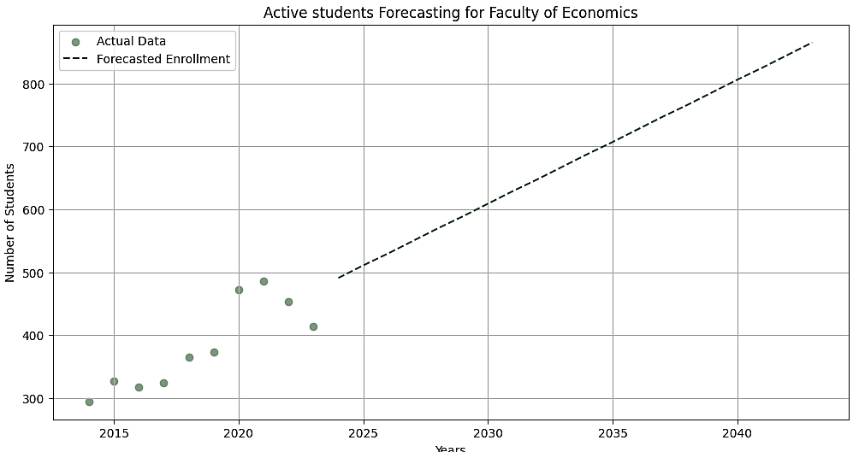

6. Faculty of Education
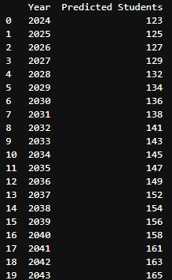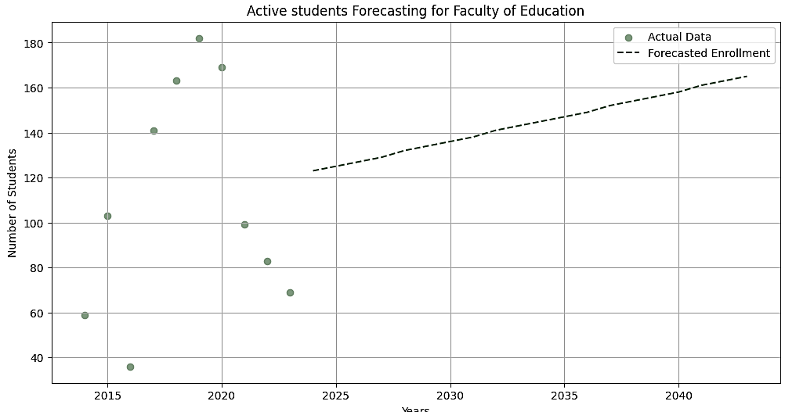

7. Faculty of Engineering
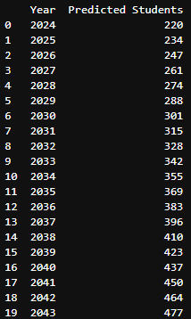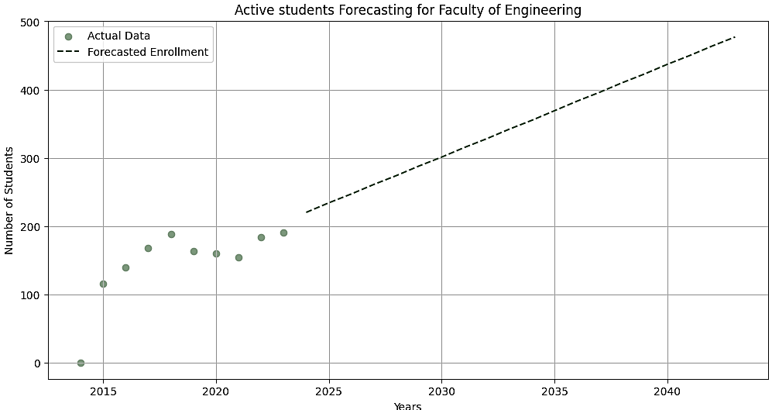

8. Faculty of Management Science
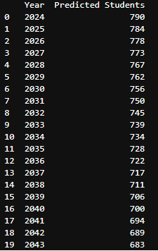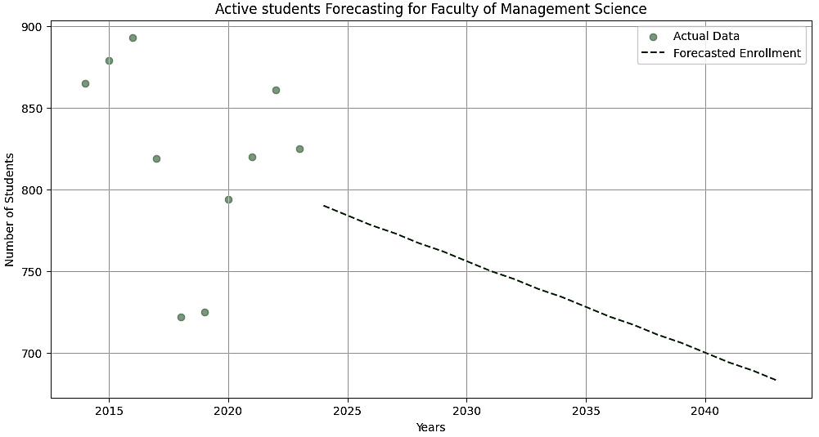

9. Faculty of Social Science
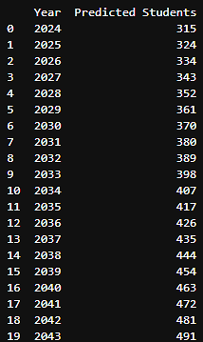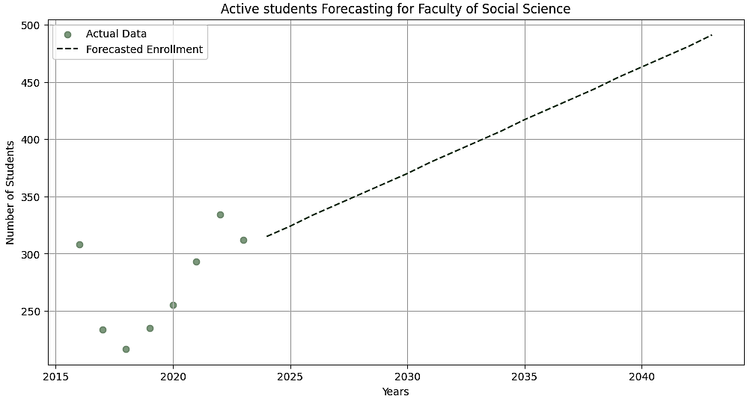
10. Faculty of Law
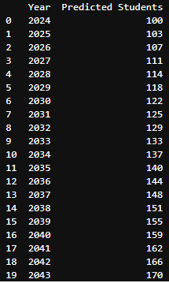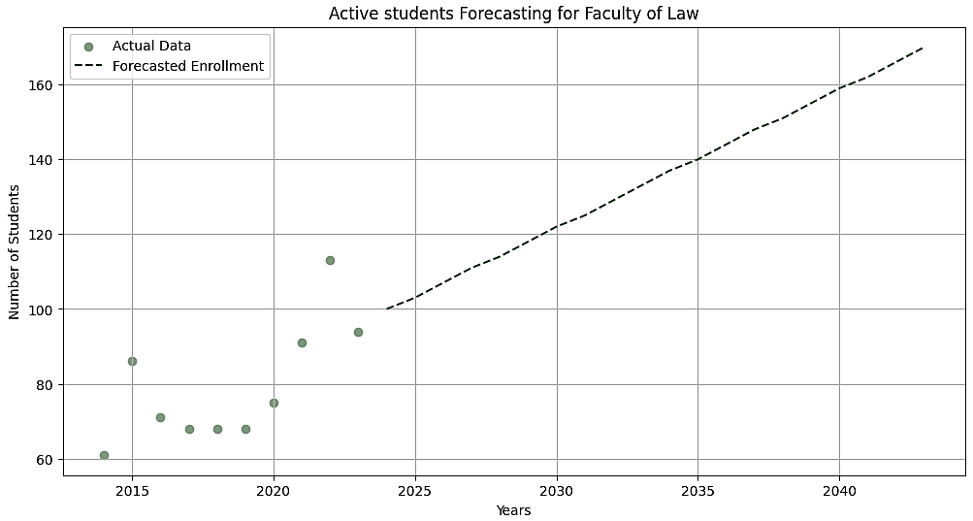

11. Medicine and Surgery program
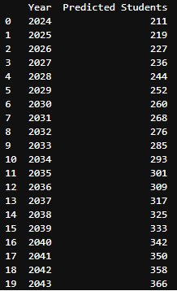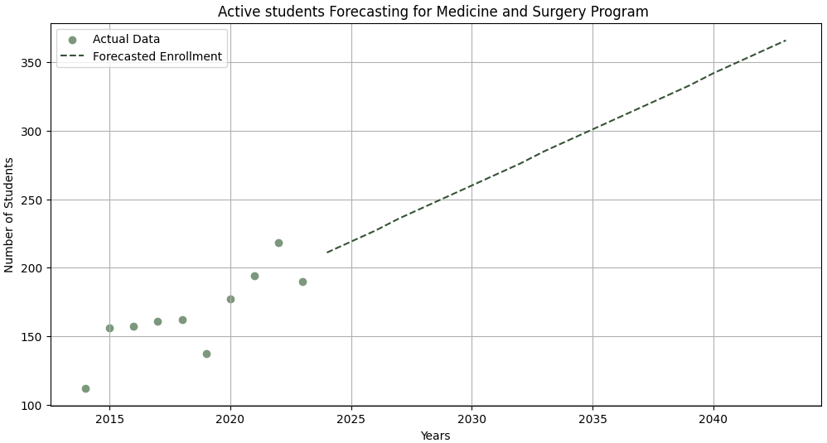

12. Health Science
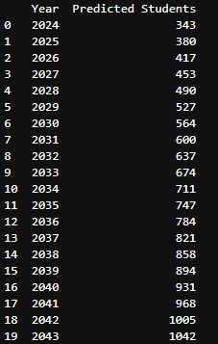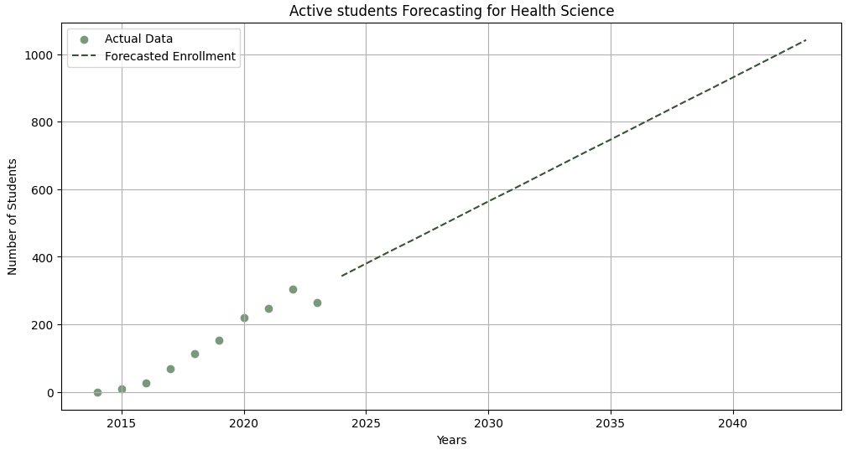

Conclusion:
Based on the trend and analysis, the departments can be classified in following three categories:
1. Upward Trend
- The overall undergrad active students have shown upward trend, with number of students in 2023 to be 3841 and then predicted students in 2043 will be 5689, showing average annual growth of about 2.41% per year.
- The medicine and surgery program has shown upward trend, with number of students in 2023 to be 190 and then predicted students in 2043 will be 366, showing average annual growth of about 4.63% per year.
- The master’s program has shown upward trend, with number of students in 2023 to be 381 and then predicted students in 2043 will be 1585, showing average annual growth of about 15.80% per year.
2. Downward Trend
- The Faculty of Management Science has shown downward trend with number of students in 2023 to be 825 and then predicted students in 2043 will be 683, showing an annual decline rate of
about -0.86% per year

